January 9, 2022 ~ The Baptism of Jesus ~ I have called you by name
Speak Lord, your servants are listening. Amen.
I don’t normally make New Year’s Resolutions. But I have decided upon this one. And I will even add it as one of my goals for 2022 in the parish annual report. Here it is and it has an impact on all of you too. My New Year’s Resolution is to teach you a Bible verse each and every week throughout 2022. The Bible is the inspired word of God and I think it is meaningful to learn more Bible verses by heart. I am not sure yet how I am going to do this but I will be doing it in my weekly sermons.
I will pick a Bible verses from the scripture appointed for the Sunday, a verse that speaks to me, that draws me into the narrative of the power of God. Here is the verse for this week:
“I have called you by name, you are mine.” Please say it with me. It is from Isaiah 43:1
Isn’t this a beautiful thing? The Lord loves us so much. He calls us by name and we are his. We have a God who passes with us through the floods in our lives, through the fires in our lives. Our God loves us and we are precious in God’s sight.
Every year at this time, we celebrate the baptism of Jesus. Suddenly we have jumped ahead 30 years from his birth. Jesus was baptized by his cousin John the Baptist in the River Jordan. Jesus’ baptism marks the beginning of his 3 years of ministry.
In the gospel of Luke we aren’t told very much about the details of Jesus’ baptism. It is in one sentence only. “When Jesus also had been baptized and was praying, the heaven was opened, and the Holy Spirit descended upon him in bodily form lile a dove. And a voice came from heaven, “You are my Son, the Beloved; with you I am well pleased.” Luke 3:21-22
What a gesture of love and this love continues today. At our Christian baptisms we are marked as belonging to Christ forever. I sign you with the cross and mark you as Christ’s own forever. I will be baptizing a child this morning after the children’s service. She will be baptized with the names that her loving parents gave her ~ Teddi Josephine. Names are truly significant and let’s think about the Bible verse we are all memorizing this week.
“I have called you by name. You are mine.” Isaiah 43:1
God calls us by name out of love for each of us. One of the first things a tyrannical leader or government will do is to depersonalize us, to eliminate our names. Look at what happened with the millions of Jews who were murdered in the concentration camps by Hitler’s Nazi regime during World War II. When the Jewish person arrived at a camp such as Auschwitz, they were tattooed with a number on the outer side of their left forearm.
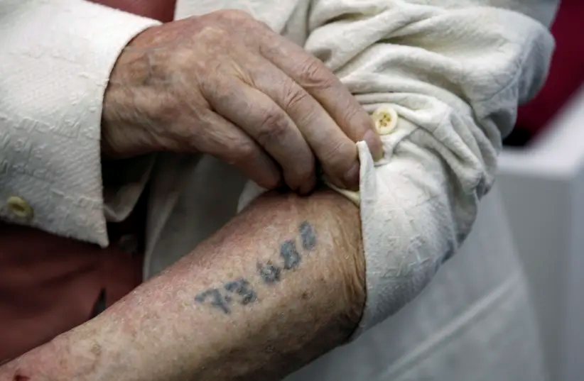
Jouni reminded me of the ending of the movie Dr. Zhivago which is the story of a man named Yuri, a surgeon and poet, who lived in Russia during the Russian Revolution and the Second World War. At the end of the movie we find out that thehe love of his life, Lara, disappears in a Stalin-led concentration camp. Here is the actual phrase used at the end of the movie: One day Lara went out and did not come back … She died or vanished somewhere, forgotten as a nameless number on a list which was afterwards mislaid.
When I listen to couples who are struggling with their relationship, I have come to know that the empathy is gone, that the love is gone, when the couple refuse to call the other person by name. They begin to refer to the person as HE or SHE and never by their name.
Names have power, especially our Christian names.
I had the privilege of baptizing all 12 of our grandchildren beginning with James Nelson and going until Oliver Olavi Elwood’s baptism in Kempele, Finland just a couple of months ago. I will never forget asking their parents to name their beloved child. I then repeat the names and baptize the child. I will be doing the same with little Teddi Josephine this morning.
Baptism is the first sacrament in our Christian journey. And then we renew our baptismal vows at our confirmations. When our 4 children were baptized as infants, I found myself calling their baptisms their christenings. This is a term still used in England. The child receives their names and becomes a Christian, a disciple of Jesus, through their baptisms. I must say that I used to like the name christening. Today though my focus is on baptism. The sacrament of the outward sign of water poured on the candidate 3 times in the name of the Holy Trinity ~ the Father, the Son, and the Holy Spirit.
I am truly impressed that through their many moves, my parents held on to my baptismal certificate. It is so important to me that I keep it in the Bible that I pray with. Here it is. I SHOW THE CERTIFICATE TO THE CONGREGATION AND THE LIVE STREAM.
When I was less than 2 months old, I was baptized on September 13, 1953 in the name of the Father, and of the Son, and of the Holy Ghost by Rev. Arthur Lavender in Terrace Bay Community Church. Years later after I was ordained a priest, I was invited back to the Thunder Bay Community Church and asked to preside at the funeral of a close family friend a man named Monty Paget. I had not been back in that church since we moved away in 1956 when I was 3 years old. I will never forget how I felt walking into the church and looking at their baptismal font. The years and the decades faded away and I was filled with gratitude for the gift of baptism that my parents arranged for me. Baptism is so significant for us as Christians. I continue to be overwhelmed at the grace that you and I have received in holy baptism.
One of the greatest privileges of being a priest is being able to be God’s instrument through baptism. I can’t even imagine how John the Baptism felt when he baptized Jesus. Jesus would have been baptized with his Aramaic name of Yeshua. Imagine the heavens opening and the Holy Spirit descending. And hearing the voice of God calling Yeshua his beloved.
Back to the Bible verse. Do you remember what it is?
I have called you by name. You are mine. Isaiah 43:1
I invite you to think about the people you love, even if they have passed away and have gone to heaven to be with God. Say their baptismal names out loud. Think about how they were anointed with the Holy Spirit at their baptisms. If you are not yet baptized, it is never too late. This sacrament gives you strength and peace and power. To be filled with the Spirit of God is one of the most beautiful things that can happen to a human being. Ann Camber from this parish will be ordained as a deacon in the church of God next Saturday evening at 5 pm. God knows her and recognizes and loves us and will mark her for her new ministry.
A meaningful time in my ministry was when a dying man asked me to baptize him. He was in St. Joe’s. It was December 1, 2005. This man and I went to the chapel at St. Joe’s, along with his family. I baptized him with his Christian names of Carl Cochrane and then he received his first communion. I will never forget the joy in his eyes and his awareness that he was marked as belonging to Christ forever. Carl lived 3 more days and died on December 4, 2005. Imagine when Jesus received him into heaven and said:
I have called you by name. You are mine.
Amen.

